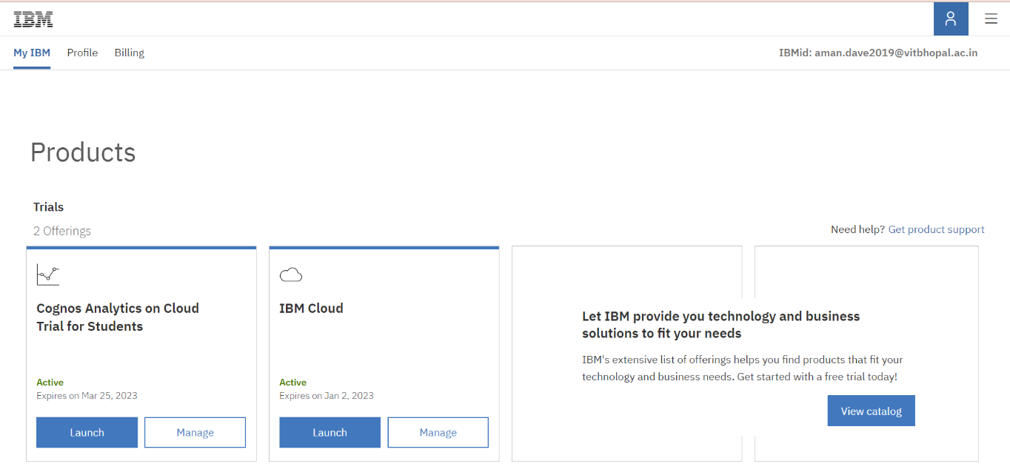Activity 1: IBM Account Creation

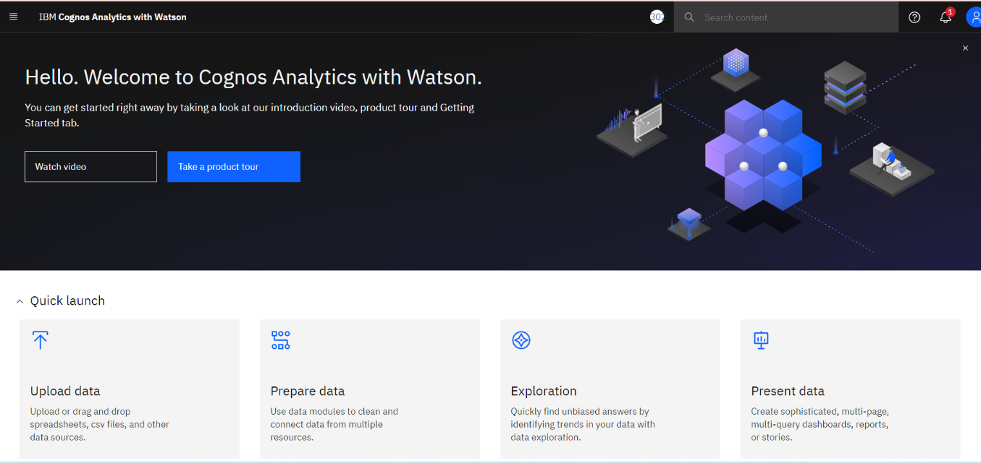Activity 2: Create Cognos Analytics Account

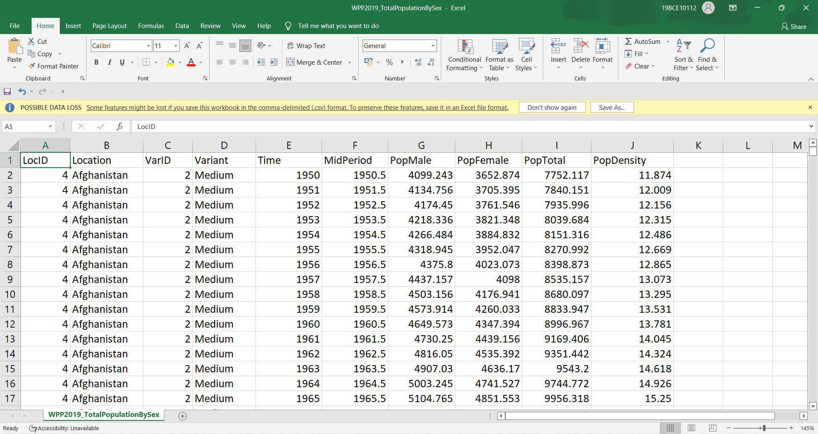Activity 3: Understand The Dataset

Activity 4: Loading The Dataset

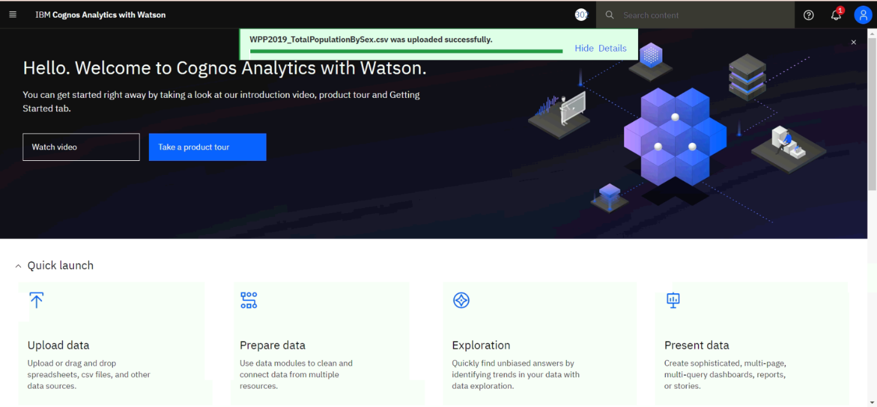

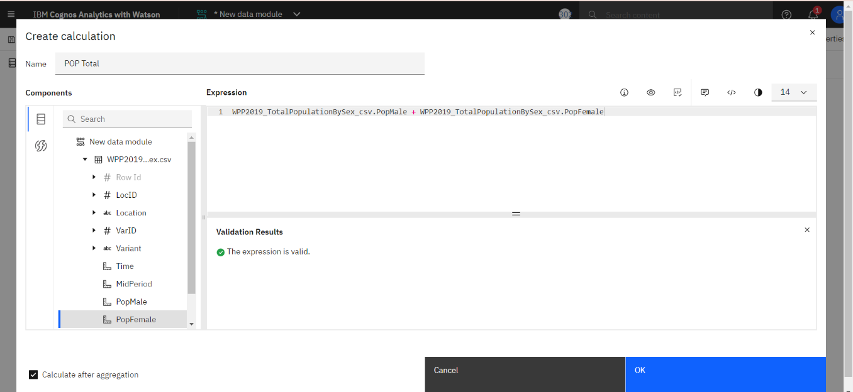Activity 5: Prepare The Dataset

Activity 6: Top10 Pop Total By Location Using Tree Map

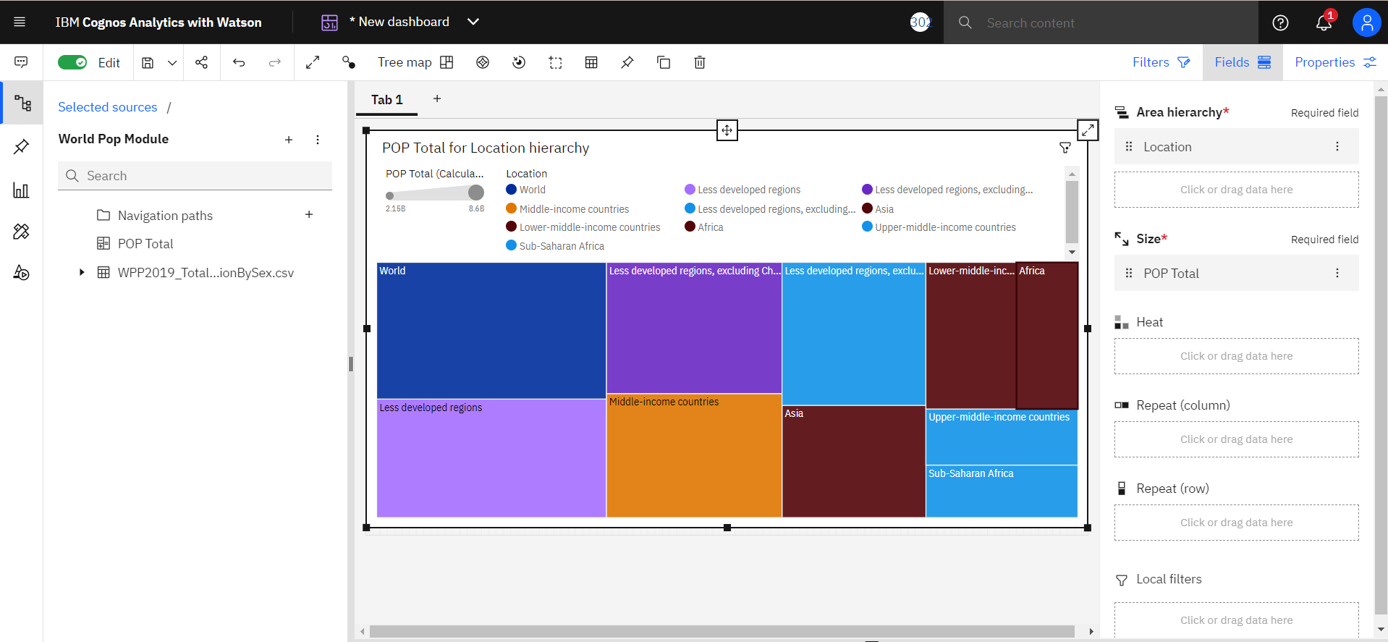

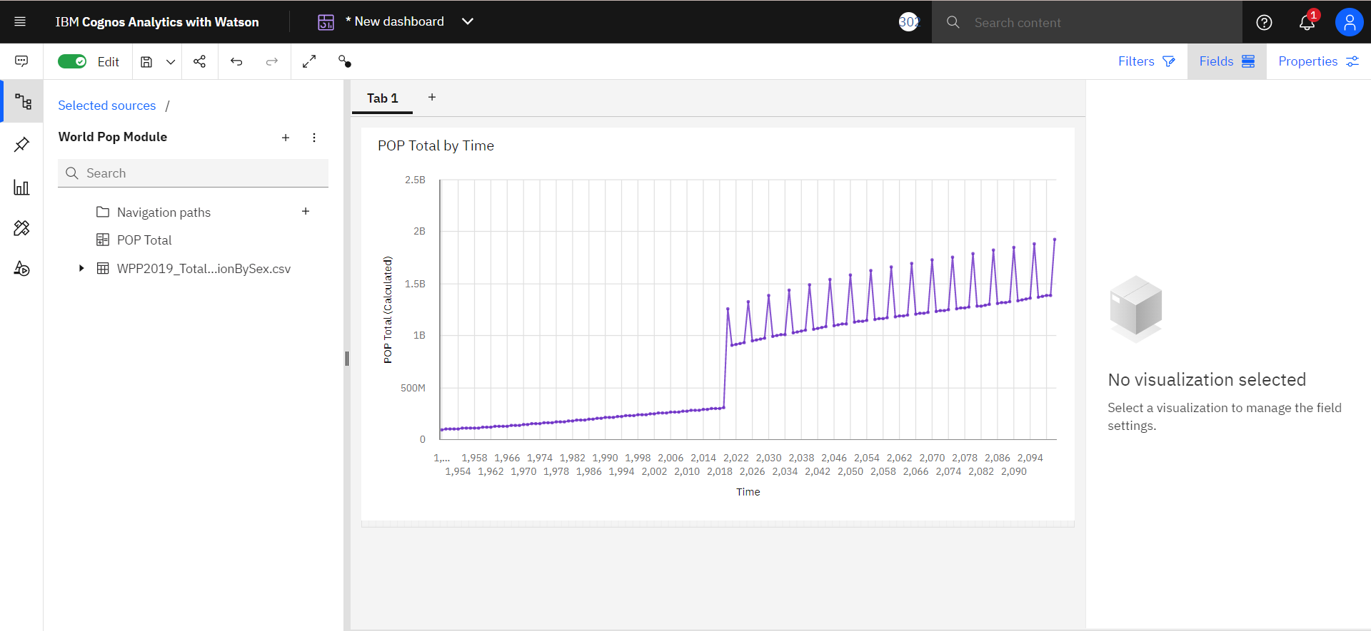Activity 7: Pop Total By Time Using Line Chart

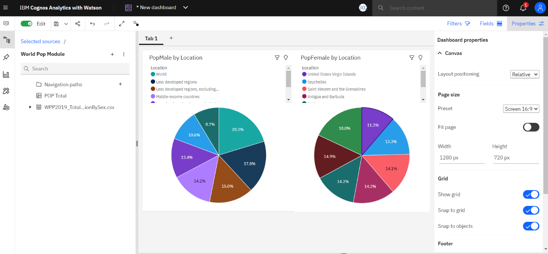Activity 8: Pop Male By Location And Pop Female By Location Using Pie Charts

Activity 9: Pop Male By Time And Pop Female Using Packed Bubble Charts

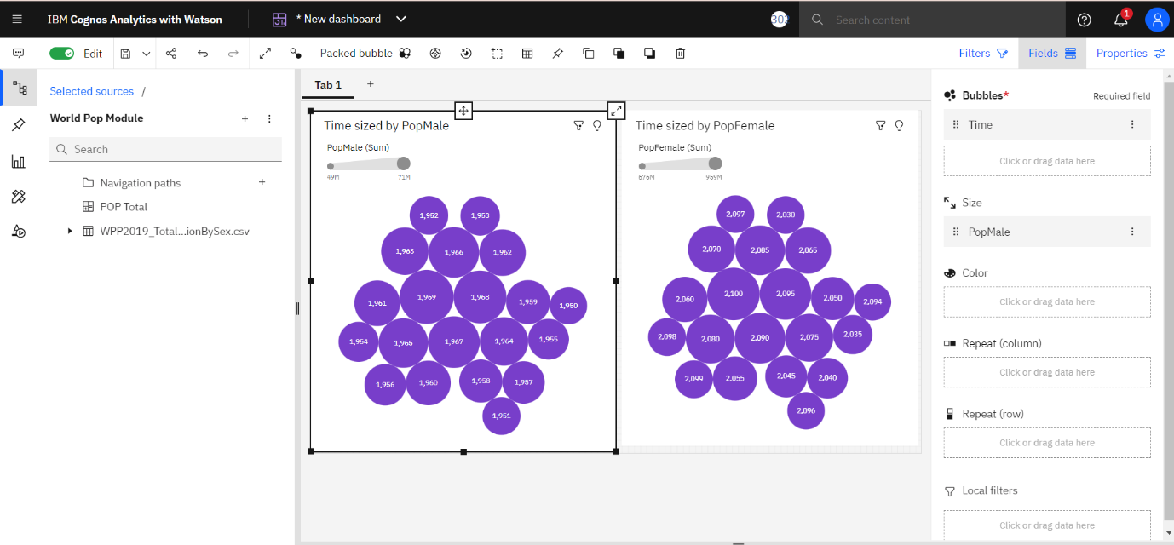

Activity 10: Building Of Dashboard

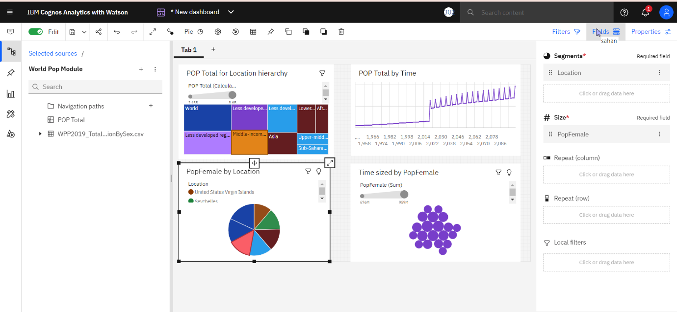

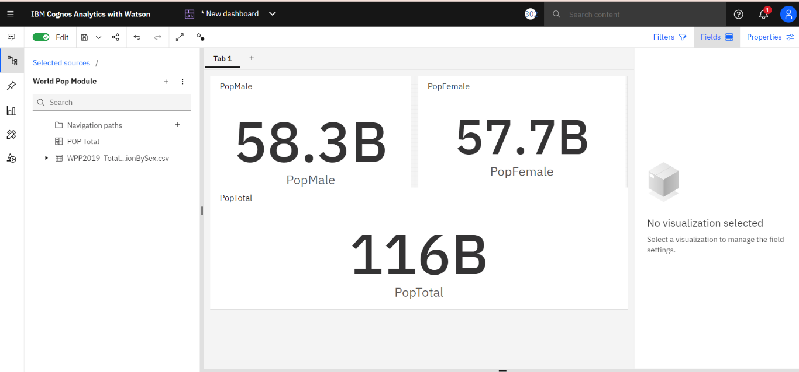Activity 11: Pop Male, Pop Female And Pop Total Using Summary

\*\*\*\*\*\*\*\*\*\*\*\*\*\*\*\*\*\*\*\*\*\*\*\*\*\*\*\*\*\*\*\*\*\*\*\*\*\*\*\*\*\*\*\*\*\*\*\*\*\*\*\*\*\*\*\*\*\*\*\*\*\*\*\*\*\*\*\*\*\*\*\*\*\*\*\*\*\*\*\*\*\*